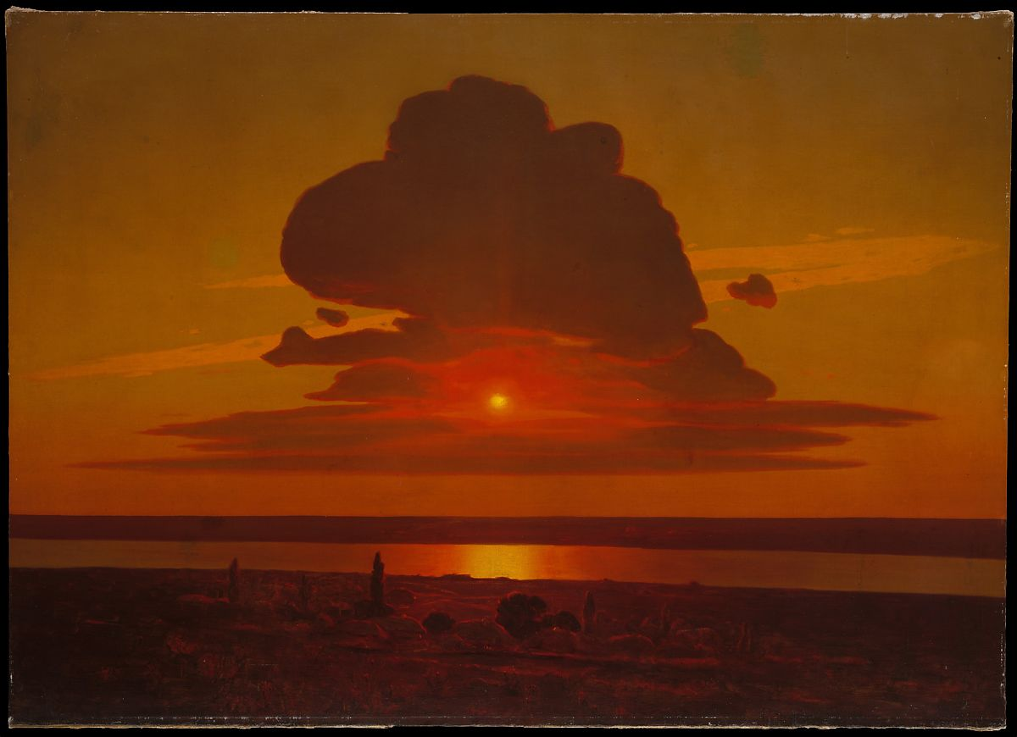

Arkhyp Kuindzhi, Red Sunset, Metropolitan Museum of Art

DON’T SPEAK A SLAVIC LANGUAGE? NO PROBLEM!   
THESE SPRING 2024 COURSES HAVE NO PREREQUISITES!

RUSS 3221 RUSS 3222  
**Literature & Revolution**  **Tolstoy & Dostoevsky**  
*J. Merrill,* TR 2:40 – 3:55 *L. Knapp*, MW 10:10 – 11:25  
  
RUSS 3230 CLSL 4000  
**Trickster in World Culture (Global Core)**  **Hebrew: History, Politics, Culture, Literature***M. Lipovetsky,* TR 11:40 – 12:55 *O. Dynes,* W 4:10 – 6:00   
CLCZ 4035 GEOR 4042   
**Writers of Prague**  **Expressive Culture of Soviet and Ind. Georgia**  
*C. Harwood, TR, 2:40 – 3:55*  **(Global Core)**  
 *L. Ninoshivi, W 10:10 – 12:00*   
  
UKRN 4054 CLRS 4113  
**Creating Identity in Contemp. Ukraine**  **Impossible Worlds in Russian & Eng. Fict.**  
*M. Andryczyk*, TR 1:10 – 2:25  *J. Merrill*, M 4:10 – 6:00   
RUSS 4126 CLRS 4215  
**Remediating Protest Thinking Socialism**  
*T. Efremova*, T 4:10 – 6:00 *A. Leeds,* T 4:10 – 6:00